EXPERIMENT 7: SECURE NETWORK ARCHITECTURE

AIM

To understand the principles of secure network architecture and learn how to design and analyze networks with proper segmentation, defense mechanisms, and security controls.

PROCEDURE

- Study the fundamentals of secure network architecture.
- Understand network segmentation, zones (DMZ, internal, external), and trust boundaries.
- Analyze different security devices such as firewalls, IDS/IPS, and proxies.
- Learn how to design layered security using the defense-in-depth approach.
- Identify risks in poorly designed architectures and suggest improvements.

QUESTIONS

TASK 1 - Network Segmentation 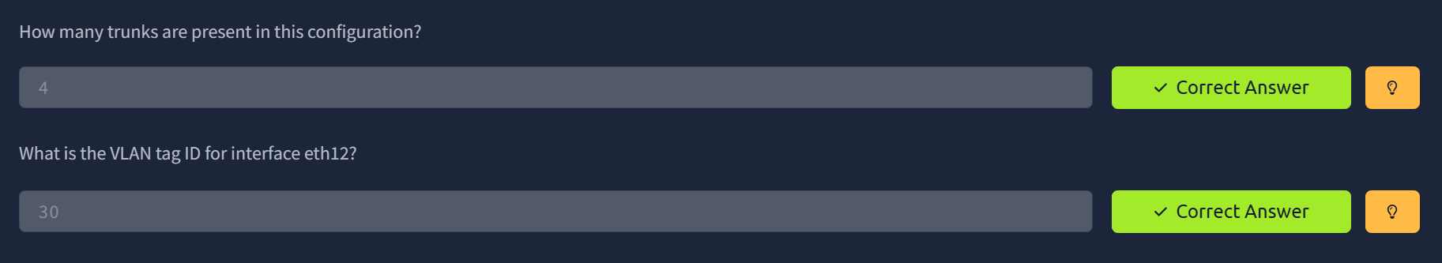

TASK 2 - Common Secure Network Architecture 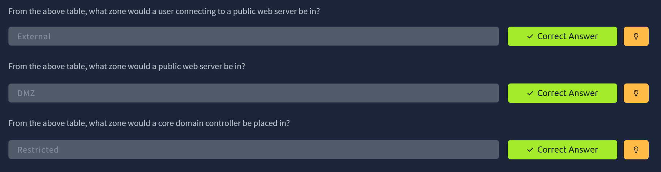

TASK 3 - Network Security Policies and Controls 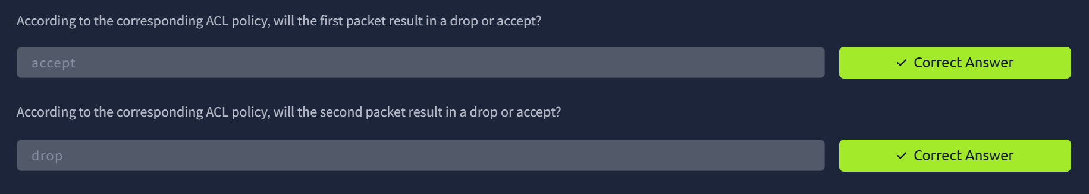

TASK 4 - Zone-Pair Policies and Filtering

TASK 5 - Validating Network Traffic 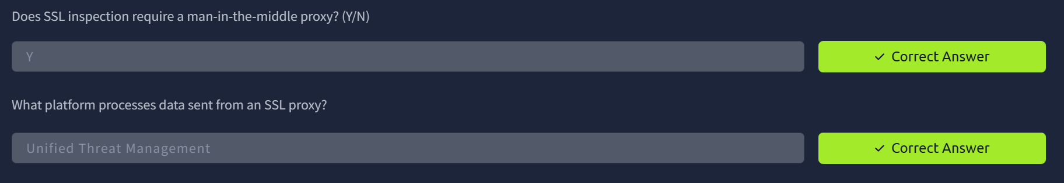

TASK 6 - Addressing Common Attacks 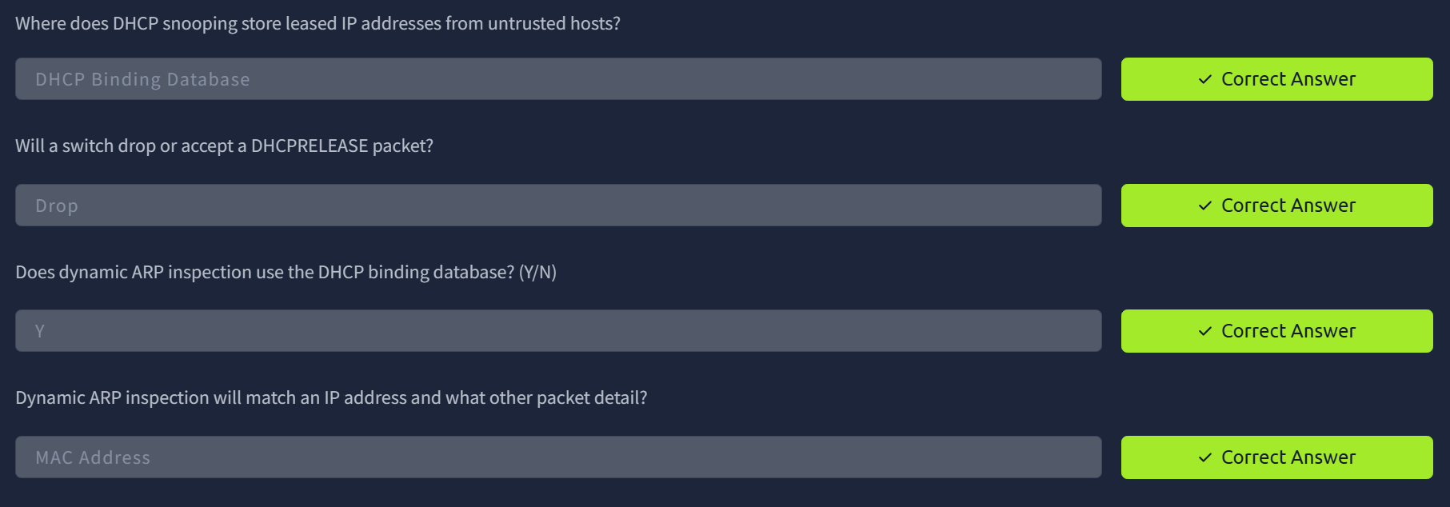

RESULT

Successfully understood secure network architecture concepts and learned how proper network design, segmentation, and layered security controls help in protecting systems from cyber threats.

